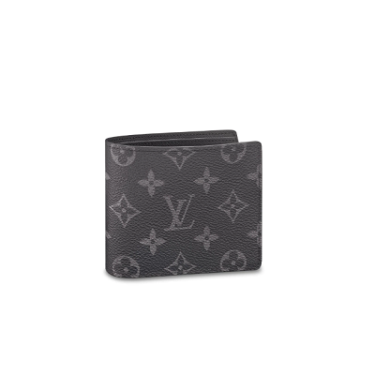

Multiple Wallet Monogram Eclipse Canvas

PRODUCT DETAILS

**- 4.5 x 3.5 inches**

**- Coated Canvas**

**- Cowhide Leather and Canvas lining**

**- Cowhide Leather filet to trimmings**

**- 3 credit cards slots**

**- 2 compartments for bills and tickets**

**- 2 side slots for receipts**

**- 2 business cards slots**

**- Made in France or Made in Spain**